COSC 4P14
Lab Assignment 1

1.1
The server (Server.java) was executed via the following command:

Once running, it was possible to find the port on which the server was running by using the netstat command in a separate terminal as follows:
The ‘lntu’ flags tell netstat to display all services that are listening for TCP and UDP. We can see that the port that the server is running on is port 4000.

1.2 – 1.3.2
The client or telnet can be used to send messages that are received and printed out by the server as shown below:
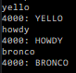
Server Client/Telnet
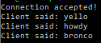

Telnet can also be used as follows:

2.1
Simultaneous pings post step 2.2:
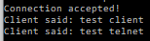

2.2
Multiple client connections:
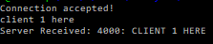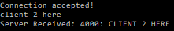
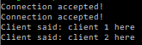
As shown above more than 1 client can now establish a connection to the server now due to the addition of multithreading. Each client is handled by its own thread.

2.3
A of step 2.3, the server will now send back to the client a response containing the port number of the client as well as the clients message to the server capitalized. This can be seen in images 1 and 2 above after “Server Received:”.

2.4
Any connected client can now send a disconnect request to the server by entering “quit”. The server will intercept this disconnect key and terminate the thread handling that clients connection, effectively terminating the socket connection while allowing the server to still process requests from any other connected clients. The disconnected client will receive and print out a confirmation message of the disconnection from the server, then its own process will be ended.

